AI-Based Glue Route Quality Inspection for Industrial Metallic Parts - Guidelines

Table of Contents

Introduction 3

Folder & Files Structure 3

Steps to Run the Application 4

Troubleshooting 5

Introduction

This guide explains how to set up, run, and maintain the glue-inspection system. The solution uses a YOLOv11 model for defect detection (Good vs NG) and a Flask web app with three pages: Upload Image, Live Detection, and Capture & Save. It supports local development (CPU/GPU) and edge deployment on NVIDIA Jetson Orin Nano (TensorRT optimized).

Folder & Files Structure
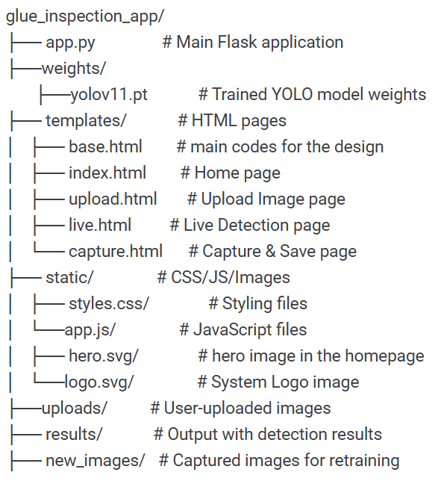
- app.py – Runs the Flask web application and links the YOLO model with the interface.

- yolov11.pt – The trained deep learning model (weights).

- templates/ – Contains HTML files for the front-end pages.

- static/ – Contains CSS and JavaScript for styling and interactivity.

- uploads/ – Stores uploaded images from the Upload page.

- results/ – Stores detection results (annotated images).

- new_images/ – Stores captured images for dataset expansion.

Steps to Run the Application

- Open the terminal

- Enter the project folder
cd ~/ glue_inspection_app

- Create a virtual environment
python3 -m venv .venv
source .venv/bin/activate

- Install dependencies
pip install flask ultralytics opencv-python torch torchvision

- Run the Flask app
python app.py

- Open in browser

Troubleshooting

Problem: Flask app doesn’t start
- Check if Python installed and also check the version (>=3.8).
- Install all requirements

Problem: No detections / always blank
- Ensure yolov11.pt is in the project root.
- Lower confidence threshold inside app.py (e.g., conf=0.25).

Problem: Camera not working
- For Jetson CSI camera, make sure to use GStreamer pipeline and if it is correct in app.py.
- Reset the camera service
sudo systemctl restart nvargus-daemon

Problem: Port already in use
- Run this command in the terminal
pkill -f "python app.py" 2>/dev/null || true

